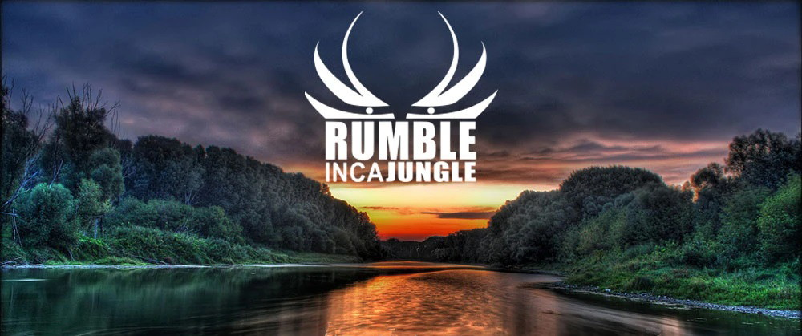

Amazon Peru
~ Guinness World Record for The Longest Continuous Concert By A Single Group ~

June 13-26, 2027 ~6 days of Jungle and Music followed by the 5 day San Juan Music & Dance Festival; the largest and most important Amazonian festival in Peru “patronal feast of the jungle”, combining Catholic tradition with Indigenous rituals around water and nature.

June 13 (Sunday): Arrival Iquitos.
Overnight local hotel.
Dinner.

June 14: Early morning boat trip up the Amazon River. Then we turn up the tributary Yanayacu de Yanapana River. This is the border of the Tamshiyacu Tahuayo national reserve (420,080 ha of protected jungle).

Late afternoon arrival at our lodge and greeting by the San Juan de Yanayacu Native Community. Lodge facilities include solar power electric, internet wifi, screened bungalows with private bath.
Overnight lodge bungalow. All meals included each day.

June 15: Lodge activities. The area is known for its huge biodiversity, with over 600 species of birds, over 10 species of monkey, dolphins, capybaras and much more.
Activities over the next days’ include:
Boat excursions to Muena and Sapote Lakes, full of large trees, sometimes dolphins, and a lot of wildlife along the edges. Sapote lake is one of the largest lakes and aids in dragon fish breeding.
- Night Hiking Excursion to see nocturnal animals such as caimans, bats, frogs, or maybe even a pygmy owl.
- Search for over ten species of monkey, looking specifically for the Howler Monkey.
- Canoeing, fishing, swimming with the dolphins, hiking another one of the trails or sail one of the lagoons in the area and learn about medicinal and industrial plants. Look for the smallest of the monkeys, the pygmy marmoset or search for capuchins.
- Visit the Amazonian village of San Juan de Yanayacu.

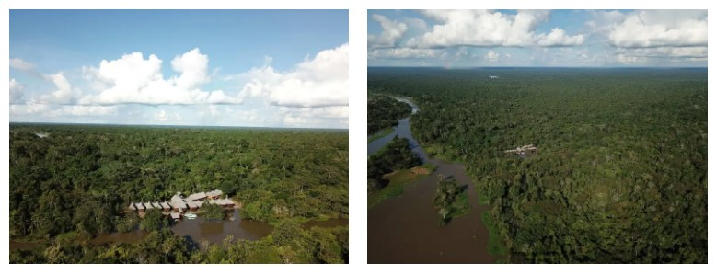

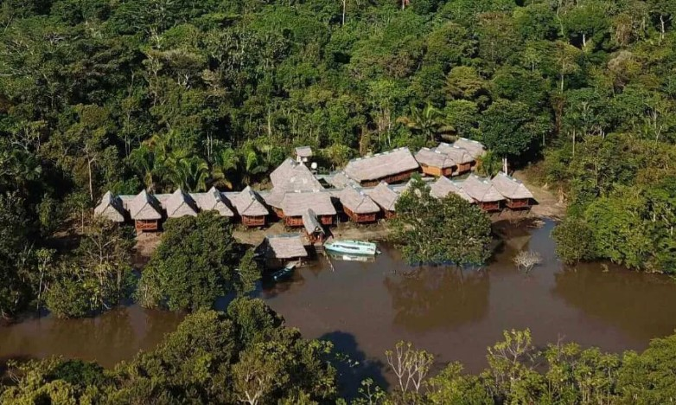

June 16: Lodge activities.
Overnight lodge.

June 17 lodge: Support crew sets up for Rumble music.
Participants free for local activities.
Overnight lodge.

June 18 Lodge (full moon) (Day01 of music – 24-hours): At 12:01 AM musicians begin the Rumble music.
Full day musicians play music.
Participants free for local activities.
Participants Overnight lodge.

June 19 lodge (Day02 of music – 15-hours at lodge and 9-hours on boat/ship): Musicians leave the lodge at 3pm to take small boats down the Yanayacu to an awaiting ship on the Amazon River, about a 3-hour trip. Support boat follows to maintain an uninterrupted video of the musician’s’ music.
Once the musicians are aboard the ship the residents of San Joaquín de Omaguas will join in overnight support of the musicians.

Note: there will be some engine noise on the Yanayacu but perhaps we can consider that as an element for the documentary.

Participants remain at lodge - Overnight lodge.

June 20 (Day03 of music – 18-hours on ship): Participants go by boat down the Yanayacu River to the awaiting ship on the Amazon River, joining the musicians. Slow sailing on the Amazon River to the port of Iquitos, arrival 6:01pm.
END OF 66-HOUR RUMBLE.
Overnight Iquitos hotel.

June 21: For those leaving Iquitos; transfer to the airport for their flight to Lima and international.

Option to stay on in Iquitos for the San Juan Festival.
Iquitos day to explore the town:
- Belén Market & the Floating City. This is a vibrant, ever-changing riverside neighborhood and market. You’ll see floating stalls during high water, local medicinal plants, exotic fruits, fish, and traditional Amazonian products.
- Casa de Fierro (“Iron House”). A striking prefabricated iron building, said to have been designed by Gustave Eiffel, located near the Plaza de Armas. It’s a piece of Iquitos’ architectural heritage from the rubber boom era.
- Museo de Culturas Indígenas Amazónicas (Museum of Amazonian Indigenous Cultures). This museum displays artifacts, musical instruments, textiles, tools, and relics from Amazonian indigenous groups. It gives insight into the cultural history of the region.
Overnight hotel.

San Juan Festival → Largest and most important Amazonian festival, strong indigenous and mestizo roots, celebrated with river rituals, food and music.
The San Juan Festival is a celebration in honor of Saint John the Baptist, the patron saint of the Amazon. During the festivities, locals gather to celebrate Peruvian culture, and it is one of the most significant events in the Peruvian Amazon, especially in Iquitos, the largest city in the Amazon rainforest.

June 22: Festival Opening ceremonies, small performances, craft fair opening; evening Music concerts, dance shows.
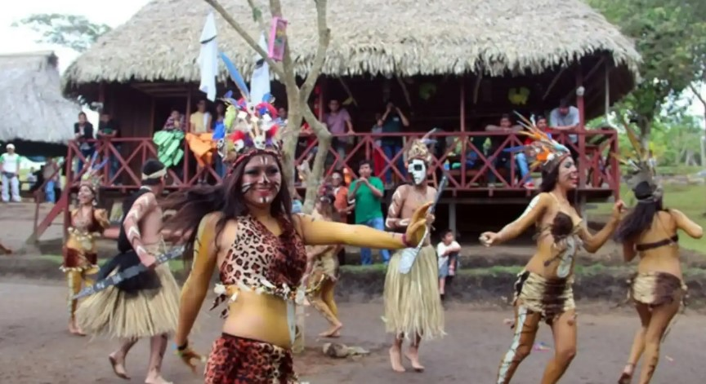
The city streets are filled with vibrant parades where both locals and tourists join the celebration, dressed in traditional costumes that represent both indigenous and Spanish culture. The rhythms of cumbia and traditional songs resonate from every corner, creating a unique festive atmosphere.
Overnight hotel.

June 23: Festival Food fairs, exhibitions, children’s events; evening Blessed bath / river rituals late at night or early morning of next day.
Overnight hotel.

June 24: Festival Main Day Mass and procession to San Juan district, more parades; Night concerts, fireworks, community party.
Overnight hotel.

June 25: Festival Photography / costume competitions, gastronomy events; Closing ceremonies, final dance parties.
Overnight hotel.

June 26: Transfer to the airport for departure.

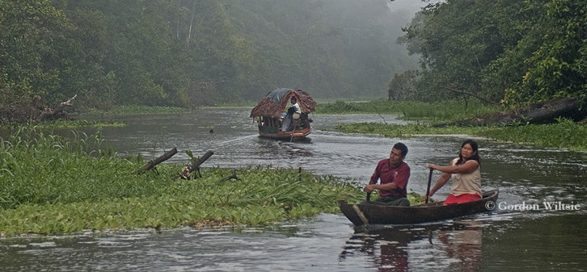

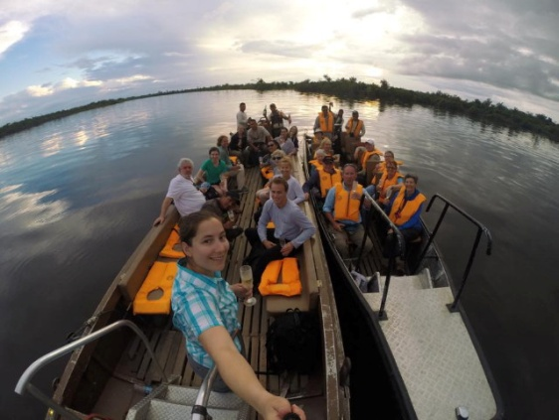 | 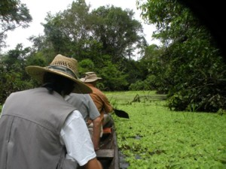

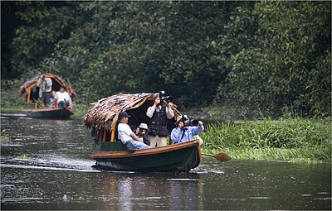 | 